Published by | Editor

HEWI
Marketing + Innovation

HEWI Heinrich Wilke GmbH
Postfach 1260
D-34442 Bad Arolsen
Phone: +49 5691 82-0
presse@hewi.de
www.hewi.com

Reprint free - specimen copy desirable

Products for children
Safety and function
HEWI offers suitable system solutions, which are especially adapted to the needs of children. Well thought-through and colourfully designed products encourage the children's independence. The products are designed so that they can be used intuitively and are easy for children to use. The topic of inclusion, i.e. the integration of children with physical limitations, is becoming increasingly important. HEWI offers solutions which allow accessibility to become a natural given. The range includes cloakroom products, benches, hardware and sanitary range products and therefore enables consistent, continuous design.
Functions suitable for children
HEWI provides well-thought through solutions for the entrance area. Cloakroom rails and benches provide plenty of storage capacity and thus create space for playing. Contrasts facilitate cognition. For example, coloured door lever fittings and window handles are easy for children to recognise, as they clearly stand out against the background.
Functional door lever fittings, window handles and handrails matching the sanitary systems are available. Their large radii make them easy for children to grip and minimise the risk of injuries. The U-shape of the door lever handle prevents the hand from slipping off while gripping and also prevents clothing from catching on the handle.
Colourful design
Coloured accents also extend throughout the sanitary systems. HEWI offers functional and robust accessories, which offer diverse design options thanks to the large choice of colours and materials. The functional areas of the sanitary System 800 K products are highlighted in colour and facilitate intuitive usability. In addition, HEWI offers accessible fitout products which, due to their reduced design, easily integrate into the sanitary systems and compensate for limitations.

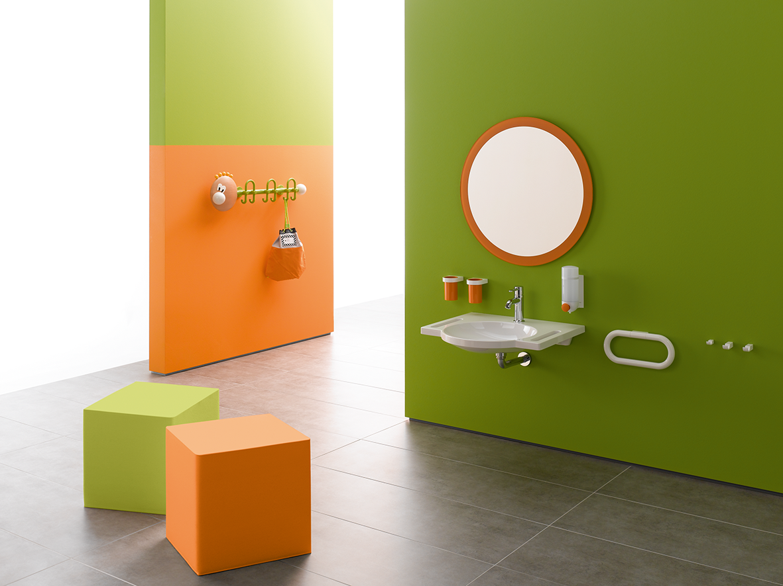
System 800 K

For further information:

HEWI Heinrich Wilke GmbH
Postfach 12 60
D-34442 Bad Arolsen
Telefon +49 5691 82-0
eMail: info@hewi.de
Internet: www.hewi.com

